***PROJECT REPORT ON* *WEBSITE FOR CODING PRACTICE***

|  |  |  |  |
| --- | --- | --- | --- |
| ***NAME*** | ***ROLL NO.*** | **SECTION** | **REG. NO**. |
| **AMIT KALITA** | **19** | **K19HZ** | **11910112** |
| **NILANJAN MAJUMDAR** | **20** | **K19HZ** | **11910126** |
| **ABHAY RAJ** | **21** | **K19HZ** | **11910143** |

***Submitted to : MANU BALI***

**COURSE:CSE326**



** FLOW CHART**

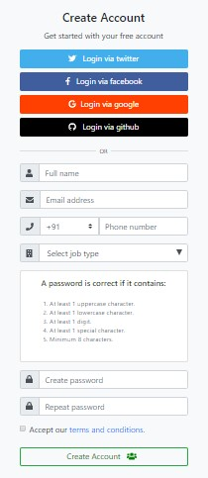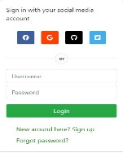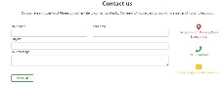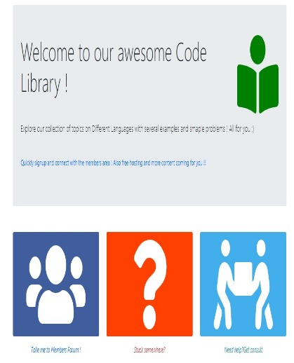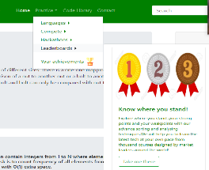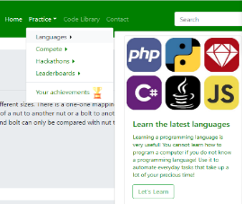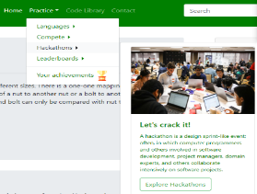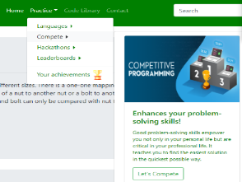

**Acknowledment**

We have taken efforts in this project. However, it would not have been possible without the kind support and help of many individuals and organizations. We would like to extend my sincere thanks to all of them.

We are highly indebted to **MANU BALI** for their guidance and constant supervision as well as for providing necessary information regarding the project & also for their support in completing the project and encouragement which help us in the completion of this project.

My thanks and appreciations also go to my colleague in developing the project and people who have willingly helped me out with their abilities

**INTRODUCTION**

###### 

ComputerGeeks.com *CODE WANTS TO BE SIMPLE* is an initiative to help the upcoming programmers with the code. Scan code focuses on providing the most efficient code or snippets as the code wants to be simple. We will help programmers build up concepts in different programming languages that include C, C++, Java, HTML, CSS, Bootstrap, JavaScript, PHP, Android, SQL and Algorithm

While designing our website we used **HTML, CSS, JAVASCRIPT and BOOTSTRAP** framework.

In the top part (shown below) of this website i.e. green area, there are many options present   
like HOME, PRACTICE, CODE LIBRARY, CONTACT, SEARCHBAR, LOGIN\SIGNUP option.



When we move the cursor and touch the practice option the website automatically pop  
Four new options.

Those are :

**1**: Language  
 **2**. Complete

**3**. Hackathon

**4**. Leather board

**5**. Your Achievement

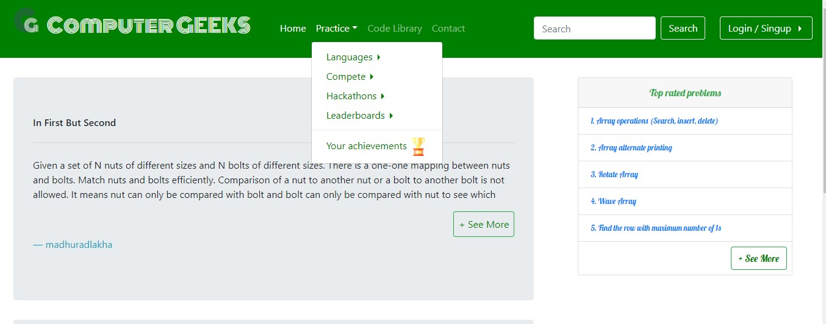

Again if we point the cursor to the language option then this website automatically show  
many programming language icons without any click.

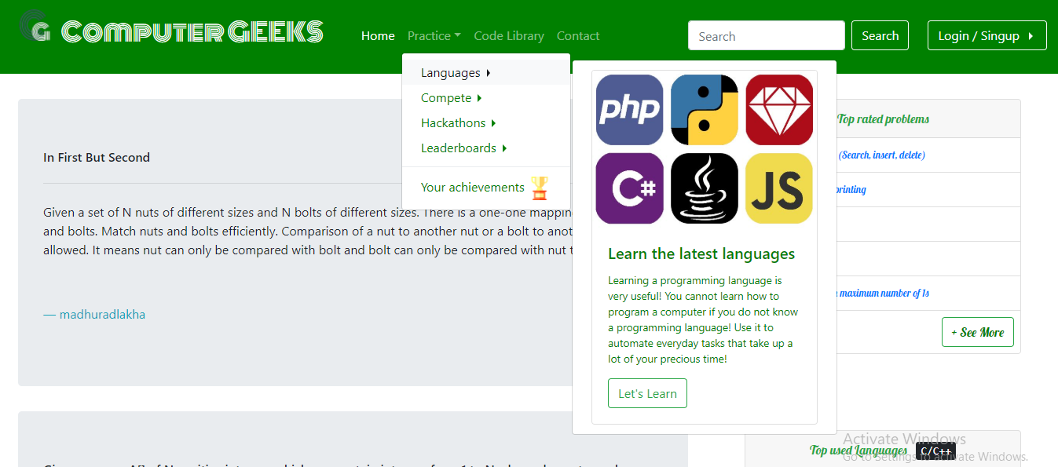

OTHER three options are also shown in below screenshot

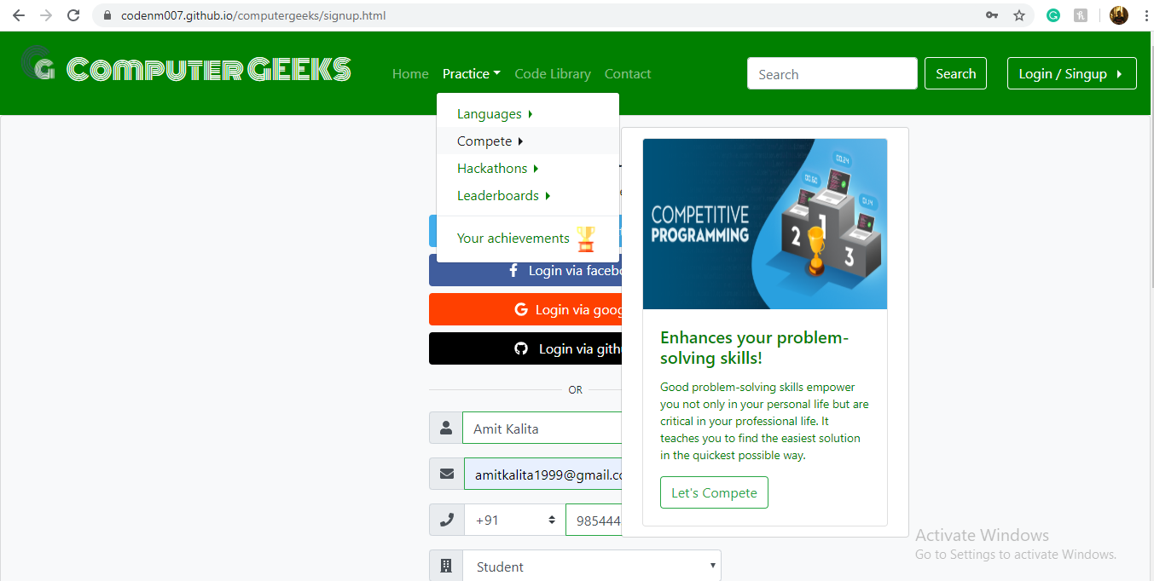

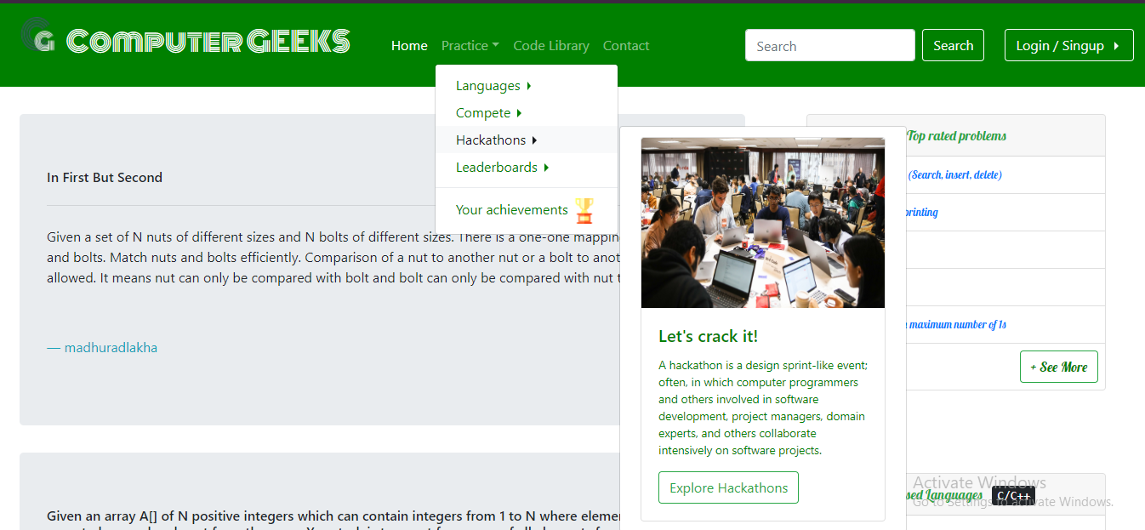

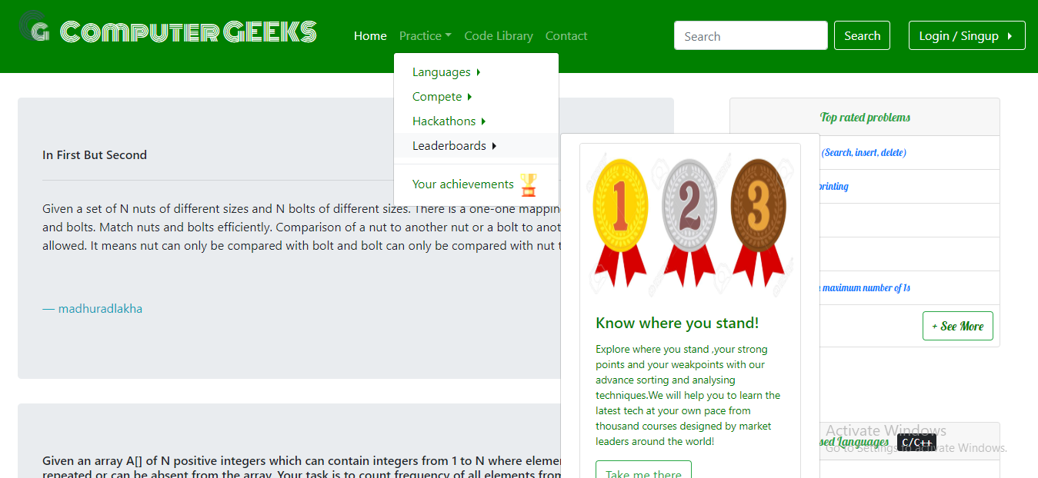

We implement CSS to enable this attribute.

By click on **code library** link, the website brings to another page, where the member forum,

Need help, get consult options are there

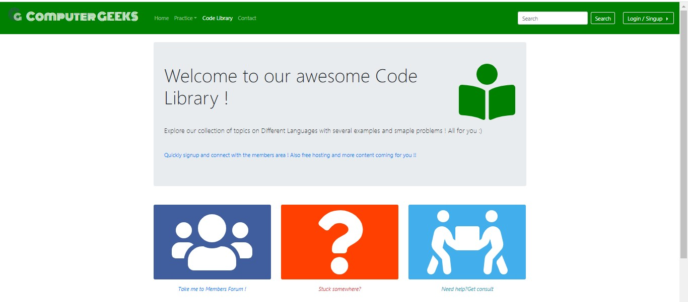

In spite of Home option, if we click ComputerGEEKS (this option present in above screenshot`s green area) option the website is also brought to Home page from any  
location of the website

**ABOUT CONTACT US LINK**

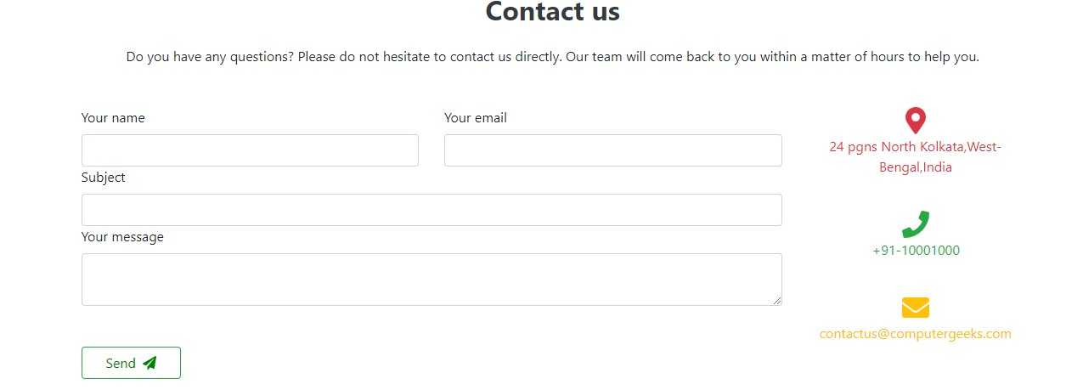

One smart feature of our website is that the **user can`t put a wrong email id.**

If you put wrong email id (Ex. without **@**) this site will show that

Email id much contains **@** with a domain name.

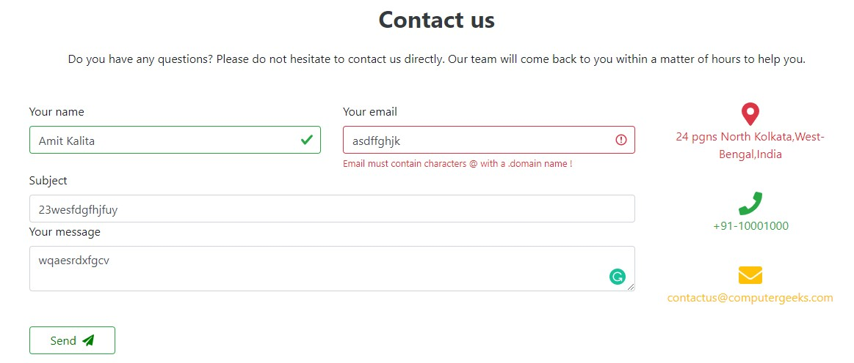

We implement this feature by bootstrap

On the Home page, there are two questions present.  
  
A link namely (**+see more**) is added below in every question  
.   
This **+see more option is created by CSS**

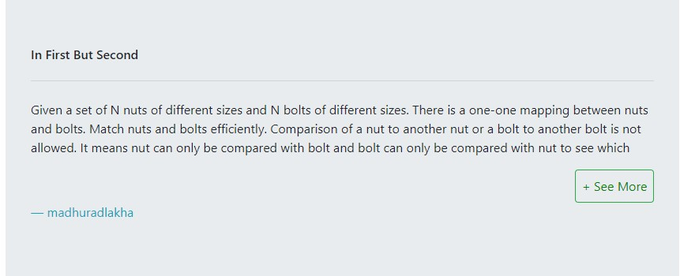

By hover **+ see more** the link will open.

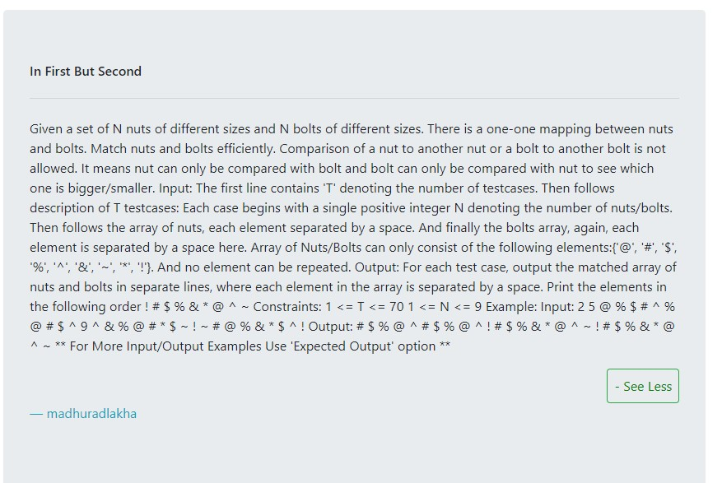

The home page also contains another two questions



We can see those question by hover

In the same way hover   
the link brings back to the previous two questions

On the Home page, we added some top-rated problem those are shown in below screenshot

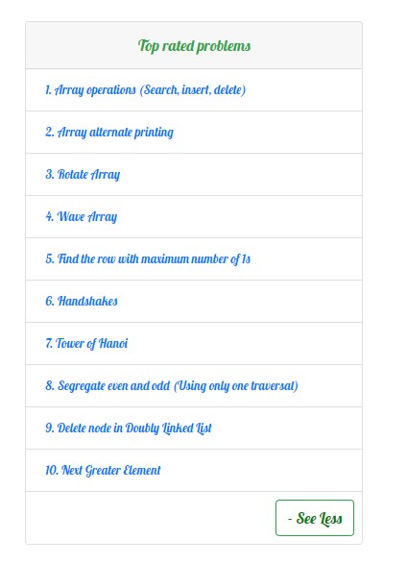

We have also introduced some top-rated programming language`s name on the Home page.

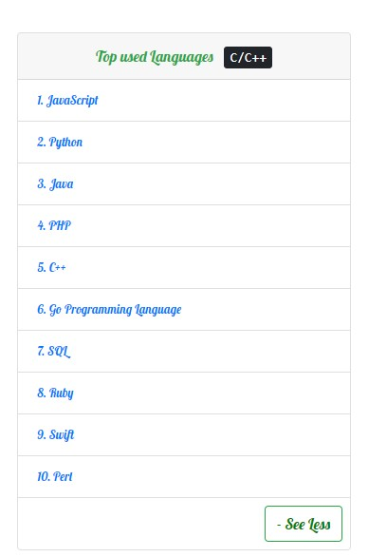

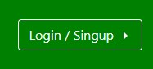

LET`S come to the most trendy, intuitive design and user interface i.e **Login / Signup**

On moving the cursor to the Login/ Signup option link, it’s spontaneously changed the colour

From green to white and also pop up a screen that is manifest in the below figure.

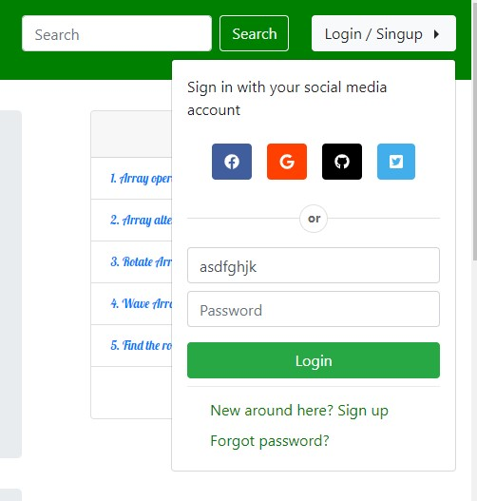

When we hover on New around here? Sign up link, then a new page opens

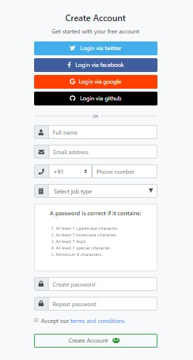

This page is used to register or Sign up the users

Though We don’t create a server to store data of the user, this page has some fascinating characteristics which will describe below.  
  
  
  
  
  
  
We implement as exactly similar aspect used in contact us link,

You can`t put anything on the email address.  
  
  
  
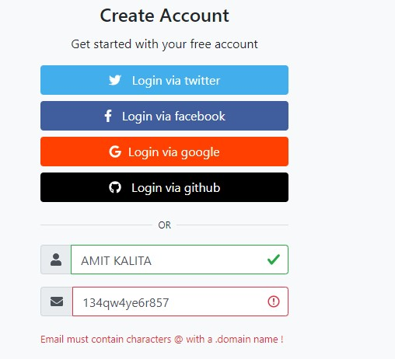

The website will show above page if users put wrong email id

In a similar way, we can not put a letter, character, symbols, emoji on phone number section

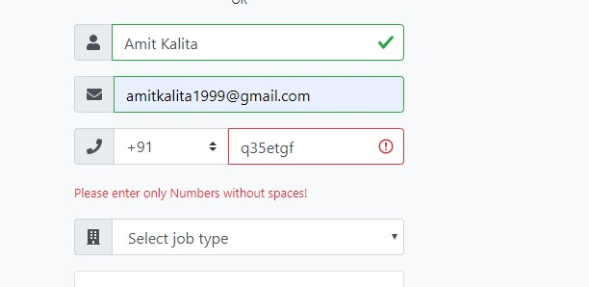  
The website will send an indication that please enter only numbers without space  
  
So, we have to put the only number in the phone number section, like below given  
Screenshot  
  
  
  
  
  
  
  
  
  
  
  
  
  
  
  
  
  
In the password section, while creating password we should keep in mind the below-mentioned terms and conditions  
  
  
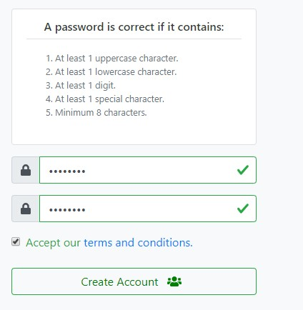  
Also, both the 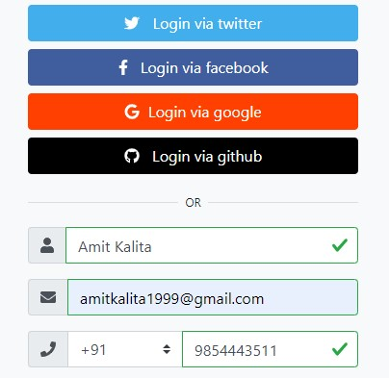

password section (create password and repeat password ) should be the same.  
  
Otherwise, the website will show like that screenshot  
  
  
  
  
  
  
  
  
  
  
  
  
  
  
 **THIS IS THE OVERVIEW OF OUR WEBSITE**